|  |  |  |
| --- | --- | --- |
|  | **Faculty of Computing, Engineering and Science** | Final mark awarded:_____ |

**Assessment Cover Sheet and Feedback Form 2017-18**

|  |  |  |  |
| --- | --- | --- | --- |
| Module Code: SE4S701 | Module Title:  Mobile Application Development | | Module Lecturer:  Abdulkareem Karasuwa, Berndt Muller, Peter Plassmann, Ian Wilson |
| Assessment Title:  A Learning App on Android | | | Assessment No.  1 |
| No. of pages submitted in total including this page:  Completed by student | | | Word Count of submission  (if applicable): Completed by student |
| Date Set:  29-Jan-2018 09:00 | | Submission Date:  20-Apr-2018 23:59 | Return Date:  18-May-2018 23:59 |

|  |  |
| --- | --- |
| ***Part A: Record of Submission (to be completed by Student)*** | |
| **Extenuating Circumstances**  If there are any exceptional circumstances that may have affected your ability to undertake or submit this assignment, make sure you contact the Advice Centre on your campus prior to your submission deadline. | |
| **Fit to sit policy**:  The University operates a fit to sit policy whereby you, in submitting or presenting yourself for an assessment, are declaring that you are fit to sit the assessment. You cannot subsequently claim that your performance in this assessment was affected by extenuating factors. | |
| **Plagiarism and Unfair Practice Declaration:**  By submitting this assessment, you declare that it is your own work and that the sources of information and material you have used (including the internet) have been fully identified and properly acknowledged as required[1]. Additionally, the work presented has not been submitted for any other assessment. You also understand that the Faculty reserves the right to investigate allegations of plagiarism or unfair practice which, if proven, could result in a fail in this assessment and may affect your progress. | |
| **Intellectual Property and Retention of Student Work:**  You understand that the University will retain a copy of any assessments submitted electronically for evidence and quality assurance purposes; requests for the removal of assessments will only be considered if the work contains information that is either politically and/or commercially sensitive (as determined by the University) and where requests are made by the relevant module leader or dissertation supervisor. | |
| **Details of Submission:**  Note that all work handed in after the submission date and within 5 working days will be capped at 40%[2]. No marks will be awarded if the assessment is submitted after the late submission date unless extenuating circumstances are applied for and accepted (Advice Centre to be consulted). | |
| You are required to acknowledge that you have read the above statements by writing your student number(s) in the box: | Student Number(s):  **14031329** |

**IT IS YOUR RESPONSIBILITY TO KEEP RECORDS OF ALL WORK SUBMITTED**

|  |
| --- |
| **Part B: Marking and Assessment**  **(to be completed by Module Lecturer)** |
| This assignment will be marked out of 100%  This assignment contributes to 50% of the total module marks.  This assignment is bonded |
| **Learning Outcomes to be assessed** (as specified in the validated module descriptor <https://icis.southwales.ac.uk/> ):  *1) Understand and appreciate the challenges and opportunities in developing mobile applications. 2) Develop skills to design and program web applications on mobile devices. 3) Understand the different programming skills needed for developing desktop and mobile platforms. 4) Develop a capability to create mobile applications on a specific mobile platform.* |

|  |  |  |
| --- | --- | --- |
| **Feedback/feed-forward** (linked to assessment criteria):   * Areas where you have done well: * Feedback from this assessment to help you to improve future assessments: * Other comments | | |
| **Mark:** | **Marker’s Signature:** | **Date:** |
| * **Work on this module has been marked, double marked/moderated in line with USW procedures.** | | |
| *Provisional mark only: subject to change and/or confirmation by the Assessment Board* | | |

|  |  |
| --- | --- |
| **Part C: Reflections on Assessment**  **(to be completed by student – optional)** | |
| **Use of previous feedback:**  In this assessment, I have taken/took note of the following points in feedback on previous work: | |
| **Please indicate which of the following you feel/felt applies/applied to your submitted work**   * A reasonable attempt. I could have developed some of the   sections further.   * A good attempt, displaying my understanding and learning, with   analysis in some parts.   * A very good attempt. The work demonstrates my clear   understanding of the learning supported by relevant literature and  scholarly work with good analysis and evaluation.   * An excellent attempt, with clear application of literature and   scholarly work, demonstrating significant analysis and evaluation. | |
| **What I found most difficult about this assessment:** |  |
| **The areas where I would value/would have valued feedback:** |  |

|  |  |  |  |  |  |  |
| --- | --- | --- | --- | --- | --- | --- |
|  | Fail | Narrow Fail | 3rd Class / Pass | Lower 2nd Class / Pass | Upper 2nd Class / Merit | 1st Class / Distinction |
| Design - User Friendliness 15% | * The app is impossible or almost impossible to use * No Layout or default layout used. Components poorly aligned | * The app is very difficult to use and requires a lot of experimentation to access the functionalities implemented * An attempt was made to use layouts but on rotation the arrangement of the App's components is seriously flawed | * The app can be used after some experimentation but may have some design inconsistencies and unusual ways of using it * Layouts used that rearrange the App on device rotation with some obvious flaws. Component alignment flawed but just about usable | * The app is easy to use but leaves the user in doubt about functionality at times. Could have some design inconsistencies * Appropriate layouts used that rearrange the App on device rotation with some unobtrusive flaws. Reasonably accurate component alignment | * The app is straightforward to use, and implements most Android design principles without design inconsistencies * Appropriate layouts used that rearrange the App on device rotation with no or only hard to spot minor flaws. Very good component alignment | * The app is intuitively designed, straightforward to use, adheres to all Android design principles and has a professional 'look and feel' * Appropriate nested layouts used that perfectly rearrange the App on device rotation. Perfect component alignment |
| Report 10% | * No description of the programming problems to solve * No discussion of possible solutions (advantages / disadvantages * No decision on design choices apparent | * A very rudimentary description of the programming problems to solve * Very basic discussion of possible solutions (advantages / disadvantages), no or very little background research apparent (references) * Few and unsubstantiated design decisions made | * A good description of the programming problems to solve with minimal insight into the problems to be solved * A reasonable discussion of possible solutions (advantages / disadvantages) with some fundamental background research (references). Generic and not about THIS project at times * Most design decisions are based on previous discussion | * A very good description of the programming problems to solve providing good insight into the problems to be solved * A well-argued discussion of possible solutions (advantages / disadvantages) a good amount of background research (references). Mainly non-generic and about THIS project * Design decisions very clear and supported by an engaged discussion | * An excellent description of the programming problems to solve providing deep insights into the problems to be solved * A very well argued and deep discussion of possible solutions (advantages / disadvantages) a large amount of background research (including non www difficult references). Almost entirely non-generic and about THIS project * Well-argued and fact supported informed design decisions supported by good engagement with source reference material | * A very professional description of the programming problems to solve providing deep insight into the problems to be solved in a succinct professional manner * An excellently argued and deep discussion of possible solutions (advantages / disadvantages) with a large amount of relevant background research (including several non www difficult references). Entirely non-generic and about THIS project * Professionally argued and fact supported informed design decisions supported by excellent and deep engagement with source reference material |
| Functionality 9 functions splash screen, 5 topics present, quiz with 5 question on each topic, questions include graphics, questions asked randomly, question bank of 10 questions present, scorecard created, scorecard saved, scores supported by graphics/ date/time 35% | * Does not launch or less than 3 functions are working to some extend | * Less than half of the functions working correctly | * Approximately half of the functions are working correctly (e.g. 3 fully and another 3 with half functionality) | * Approximately 2/3 of the functions are working correctly (e.g. 4 fully and another 4 with half functionality) | * Almost all of the 9 functions are working correctly (e.g. 7 fully and the remaining 2 with half functionality) | * All of the 9 functions are working correctly. Some additional user guidance and/or features add a 'professional touch' |
| Completeness all 9 functions (see above) attempted to a more than trivial degree (even if they may not work 100%) 20% | * Only one or 2 functions attempted | * Only 3 or 4 functions attempted | * 5 or 6 functions attempted | * 7 or 8 functions attempted | * All functions attempted | * All functions attempted. Some additional user guidance and/or features/functions add a 'professional touch' |
| Testing 10% | * Testing lacks any valid meaning or was not done at all * No test plan | * Testing is poor and lacks proper meaning | * About half of the functions were tested * Tests were superficial * A rudimentary test plan was present | * Approximately 2/3 of the functions were tested * Tests covered approximately half of the possibilities to a good degree * A good test plan and some structuring of tests attempted | * Almost all of the functions were tested * Most possibilities were tested to a very good degree * A well thought out test plan that is well structured | * All functions were tested * All possibilities tested exhaustively in several test categories * A professional test plan with excellent structuring and layout |
| Quality of Code 10% | * No commenting * Code layout all over the place / random * Haphazard code that only just about works but relies on many assumptions that may not be true * No error checking (e.g. user input errors, file I/O errors) | * Poor commenting * Very little and incomplete/incorrect error checking * Code layout reasonable in places but largely inconsistent | * Some meaningful commenting * Some error checking (e.g. user input errors, file I/O errors) * Mostly reasonable code layout | * Good commenting * Code layout (i.e. indentation, spacing) correct in most places * Good error checking (e.g. user input errors, file I/O errors) | * Very good commenting * Almost complete error checking (e.g. user input errors, file I/O errors) | * Excellent commenting, only where really required and code not self-explanatory * Perfect code layout perfect and without flaws * Professional error checking (e.g. user input errors, file I/O errors, boundary errors in conditionals, array/capacitor errors, etc) |
| Self-assessment is a requirement of the coursework, you will not receive a mark until this process is complete. | | | | | | |

***[*This page was intentionally left blank*]***

Table of contents

2. Overview 3

3. Quiz app structure 4

3.1. Project file Structure 4

3.1. High level structure and execution flow (flowchart) 7

4. Quiz content choice 8

5. Fundamental programming problems and solutions 9

6. Testing methodologies 10

7. Conclusion 11

8. References 12

Appendices 1

Appendix A: 1

Appendix B: 2

Appendix C: 3

List of tables

Table 3‑1 - Project file structure 5

List of figures

Figure 3‑1 - Flowchart: Program execution flow 7

List of abbreviations

|  |  |
| --- | --- |
| IDE | Integrated Development Environment |
| PCB | Printed Circuit Board |
|  |  |
|  |  |
|  |  |
|  |  |

# Overview

In the ambit of the module SE4S701 – Mobile Application Development, this report will cover the only assignment regarding an Android application required to be developed by the students. This application consists of a teaching quiz which contains questions specifically about the Android platform, which may or may not encompass the Java programming language.

In this quiz we may find 5 topics/categories, each of which has 5 questions with images including. These questions are to be picked randomly from a databank of 10 questions. The results (plus date and time) must be permanently stored in order to consequently display them in a score card list and in a graph.

In regards to the structure of the report, the first section will cover the structure of the Android project in three different levels of detail, from the highest level (summarised) to the lowest, most detailed level using a flowchart.

Following this is a section that discusses the motives for the choice of the content of the application. Specifically, the reason why these quiz questions in particular were picked.

Next, the fundamental issues and/or topics in programming are to be discussed, with perspective to the contents being taught in the lectures.

Finally, this report will conclude on the assignment by performing a set of unit tests in order to determine the robustness of the application being developed.

# Quiz app structure

## Project file structure

The application project follows a very common structure that is found in any project generated by the Android Studio IDE.

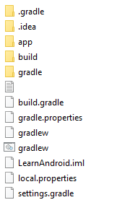

The Java code, built objects and Gradle scripts are found on the ‘app’ directory. Inside, we may find the following contents.

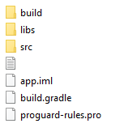

Again, the desired content is to be found inside the directory ‘src’.



This contains:

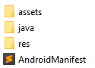

In fact, this is the main project structure found on Android Studio on the sidebar.

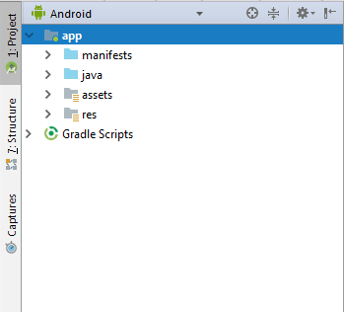

Finally, the code and the layouts for the Quiz application may be found inside the folders ‘java’ and ‘res’.

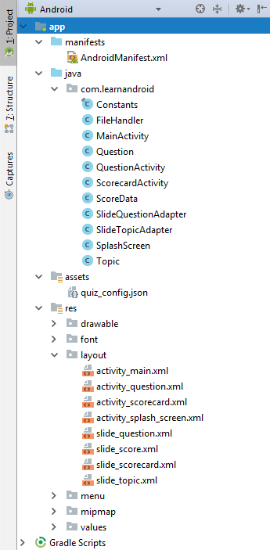

This brings attention to the following files:

|  |  |  |  |  |
| --- | --- | --- | --- | --- |
|  | Java file | Role | Layout File(s) | |
| 1 | Constants.java | Global constant values | - | |
| 1 | FileHandler.java | Util library | - | |
| 2 | MainActivity.java | Activity | activity_main.xml | |
| 3 | Question.java | Data class | - | |
| 4 | QuestionActivity.java | Activity | activity_question.xml | |
| 5 | ScorecardActivity.java | Activity | activity_scorecard.xml | slide_scorecard.xml |
| 6 | ScoreData.java | Data class | - | |
| 7 | SlideTopicAdapter.java | View controller | slide_topic.xml | |
| 8 | SlideQuestionAdapter.java | View controller | slide_question.xml | slide_score.xml |
| 9 | SplashScreen.java | Activity | activity_splash_screen.xml | |
| 10 | Topic.java | Data class | - | |
| 11 | quiz_config.json | Configuration file | - | |

Table 3‑1 - Project file structure

This table should be clear enough to describe the actual structure of the project in terms of relationships between Code ⬄ Layout.

For instance, the first column describes the Java file which has the ‘business’ logic of the application, whereas the two last columns contain the layout specifically associated with that Java file in that same row. E.g. ‘MainActivity.java’ has a layout resource associated with it, named ‘activity_main.xml’. Similarly, ‘SlideAdapter.java’, which is an adapter for controlling the main activity’s ‘ViewPager’ component also has a layout associated with it – the ‘slide_topic.xml’ XML file.

## High level structure and execution flow (flowchart)

Each of these files has a role in the entire application, as well as a relationship between the next file. In fact, there is a program flow from a specific Java file to another, and back.

On startup, the ‘onCreate()’ method of the file ‘SplashScreen.java’ is executed, as is shown on the following flowchart:

Figure 3‑1 - Flowchart: Program execution flow

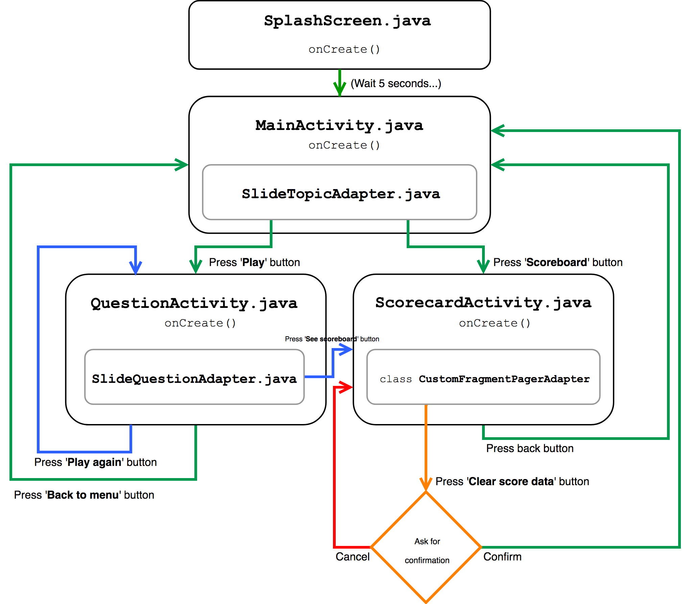

This is the underlying structure of the app. Every possibility is covered in this diagram; however, it does not describe the behaviour of the activities in themselves. This matter will be discussed on section 6 - ‘Testing methodologies’.

In addition to these Java classes, we may find other classes such as ‘Constants.java' and ‘FileHandler.java’, which are just miscellaneous static classes that deal with global values and loading and saving of files. The public quiz data which contains the actual questions is stored in JSON format, as follows:

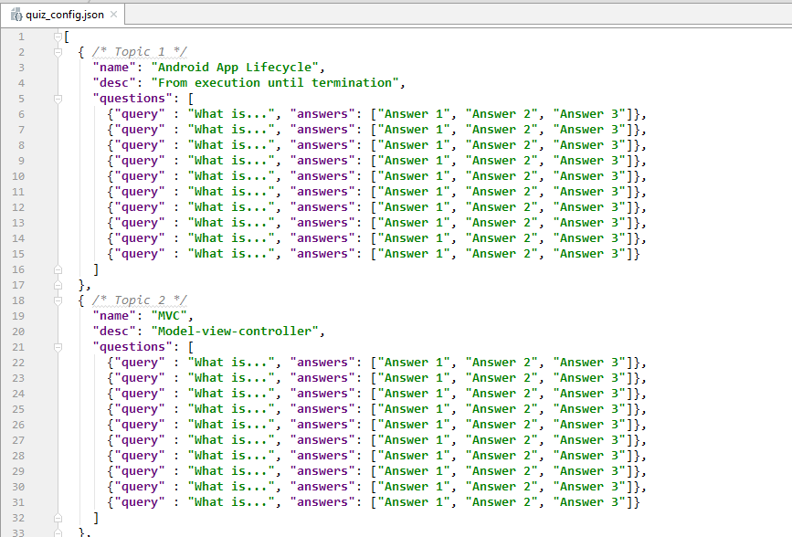

This file (‘quiz_config.json’) stores the quiz questions inside topic objects. This object also contains the name of the topics and their descriptions. As can be seen, each question inside a topic object is in the form of an array of objects, which contains a field “query” with the actual question string, followed by an “answers” field, with all of the possible answers in it. The correct answer is always the first answer in this array, so, for instance, in this given example, “Answer 1” is the correct answer.

From this, class ‘Question.java' stores the inner object (fields: “query” and “answers”), whereas class ‘Topic.java’ stores the outer object comprised of the fields “name”, “desc” and “questions”. The last class ‘ScoreData.java’ stores private user score data also in JSON format, however, this data is only stored inside the permanent storage and as such it is not available for access as opposed to the ‘quiz_config.json’ file.

As was just described, the user scores are stored in the JSON format with the keys:

1. “time” – Keeps the time and date of the question attempt;
2. “topic_index” – The topic index from which the question belongs to;
3. “correct_answers” – How many correct answers the user got on that attempt;
4. “total_questions” – How many questions did the user answer - useful to determine the score percentage (= correct_answers / total_questions);
5. “questions” – An array for each answered question that indicates which questions were answered correctly and which ones weren’t. This field also contains the index of the question that was randomly picked from the databank in this format: “{\“q2\” : \“0\”}” OR “{\“q8\” : \“1\”}”.

All values in this private JSON file are stored in string format.

The reason JSON was picked was to simplify the way questions were added to the app. Besides, JSON is extremely simple to parse (the file ‘Topic.java’ has a public static method implemented to parse this and instantiate Topic and Question objects), since it is just a key-value data structure. The last reason was to easily allow the addition of RESTful features. This way, new quiz questions may be added through a simple http request.

# Quiz content choice

# Fundamental programming problems and solutions

# Testing methodologies

# Conclusion

# References

[1] https://www.aan.com/PressRoom/Home/PressRelease/1453

[2] Maroon JC, Bailes JE. Athletes with cervical spine injury. Spine. 1996

Appendices

Appendix A:

Appendix B:

Appendix C:

1. University Academic Misconduct Regulations
2. Information on exclusions to this rule is available from the Advice Centre at each Campus